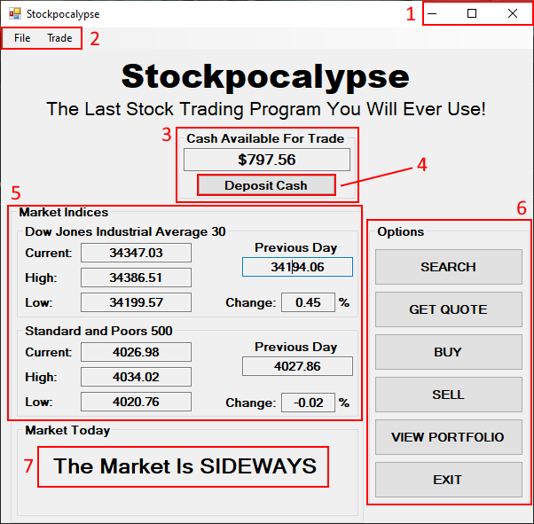
Dashboard

- Window Control (This is the same for every window in the program)
- Toolbar (This is the same for every window in the program)
- Cash Center – Displays the cash that is available for the user to trade with.
- Deposit Cash Button – Opens the deposit window, which allows the user to insert cash into their account.
- Market Daily Indices – Displays information relating to market indices that provide somewhat of an aggregate of overall market activity for the day. (DJI and S&P500 only)
- Options Panel – The entire program extends from here. The user is allowed to:
  - Search for stocks
  - Get a quote on the stock of the user’s choice
  - Purchase stocks
  - Sell stocks
  - View the user’s portfolio
  - Exit the program
- Daily Market Outlook – A simple display that shows “UP” if an index is up over 0.9% for the day, “DOWN” if under -0.9% for the day, or “SIDEWAYS” if either is true.

Search Form

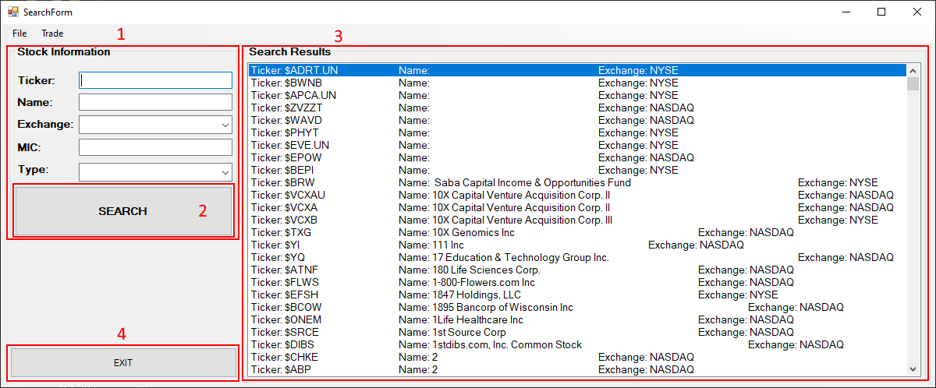
- Stock Information – For the user to insert information related to the stock that they wish to search for.
- Search Button – This is to initiate the search based on the stock information that is provided.
- Search Results – The list of stocks that relate to the information provided. It lists stocks from the NYSE and NASDAQ by default.
- Exit Button – Closes the window, then opens the dashboard.

